 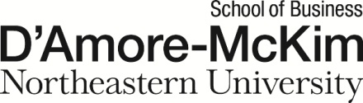

9B19A022

SOCIAL ADVOCACY AND GUERRILLA MARKETING: THE NO FLY LIST KIDS CANADA

Professor Fareena Sultan wrote this case solely to provide material for class discussion. The author does not intend to illustrate either effective or ineffective handling of a managerial situation. The author may have disguised certain names and other identifying information to protect confidentiality.

This publication may not be transmitted, photocopied, digitized, or otherwise reproduced in any form or by any means without the permission of the copyright holder. Reproduction of this material is not covered under authorization by any reproduction rights organization. To order copies or request permission to reproduce materials, contact Ivey Publishing, Ivey Business School, Western University, London, Ontario, Canada, N6G 0N1; (t) 519.661.3208; (e) cases@ivey.ca; www.iveycases.com. Our goal is to publish materials of the highest quality; submit any errata to publishcases@ivey.ca. i1v2e5y5pubs

Copyright © 2019, Northeastern University, D’Amore-McKim School of Business Version: 2019-06-05

In early November 2018, Sulemaan Ahmed was meeting with other members of the No Fly List Kids (NFLK) group to discuss the role they should play in future interactions with the Government of Canada. The NFLK group had been formed by some Canadian parents whose young children had experienced additional screening when taking flights in Canada because they had been erroneously placed on Canada’s no-fly list, officially called the Passenger Protect Program (PPP) but more commonly referred to as the “No-Fly List.” The goal of the NFLK group so far had been to persuade the Canadian government to create a redress system to prevent innocent Canadian children from being inadvertently placed on such a list. After three years of dedicated social advocacy, with its ups and downs, the group’s members wondered, what should they do next?

The Tweet that Roared: NFLK Group and its Social Advocacy Campaign

The night sky was unseasonably calm when Sulemaan Ahmed and his six-year-old son Adam arrived at Halifax’s airport to embark on an early morning flight to Boston on December 31, 2015. Adam was ecstatic to be attending the National Hockey League (NHL) Winter Classic, an annual New Year’s Day event that was among the most popular sporting events of the year. The 2016 classic featured Adam’s favourite team, the Montreal Canadiens, challenging the Boston Bruins in their first ever appearance at the classic.

As Ahmed and Adam attempted to board their Air Canada flight, a gate agent stopped Adam for enhanced screening. It was not the first time Adam had been stopped, even though Adam and his parents were Canadian citizens. Ahmed had always assumed this was because of heightened security after the September 11 attacks (9/11), and airport personnel had informed him in the past that it might be due to Adam’s name, but the family had never had conclusive proof. This time, while the agent’s back was turned, Ahmed took a picture of the agent’s computer screen to see what the problem might be. Apparently, Adam was on Canada’s Deemed-High-Profile (DHP) list of persons considered to be potential security risks. At 5:50 a.m. Eastern Standard Time, Ahmed tweeted the photo to Air Canada’s Twitter account (see Exhibit 1).The text of the tweet asked why his six-year-old, Canadian-born son was on the DHP no-fly list and had to clear security each time he flew.

In addition to tweeting Air Canada, Ahmed tagged others, including Canadian Prime Minister Justin Trudeau, then–Minister of Health Jane Philpott, then–Minister of Foreign Affairs Stéphane Dion, and Aeroplan, Air Canada’s loyalty rewards program. Adam was eventually let through, and both Ahmed and Adam boarded their flight.

When they landed in Toronto en route to Boston, Ahmed turned his phone back on to find a text message from his sister in all capitals: “CHECK TWITTER RIGHT NOW!” He opened his Twitter account and was surprised to find that, despite the early hour, his tweet was trending. Many people had retweeted the image and added notes expressing outrage about a six-year-old being placed on a no-fly list, and news reporters were sending Ahmed direct messages asking for his story. Suddenly feeling overwhelmed by the unexpected attention while travelling, Ahmed redirected all media inquiries to his wife Khadija Cajee.

The Passenger Protect Program

When Adam and Ahmed returned home on January 2, 2016, a news crew from Global National, one of Canada’s three major news networks, was waiting for them. Ahmed, seeing a chance to raise awareness of the issue, invited the news crew to his home for a formal interview with him and his wife Cajee. Later that evening, the story was posted on the Global National website, and this generated interest from other news outlets as well as public interest in Ahmed’s original tweet (see Exhibit 2).

The story also caught the attention of Zamir Khan and his wife Heather Harder, who had encountered similar problems with their son Sebastian, starting when he was just six weeks old. The first time they tried to print a boarding pass for a WestJet flight, they received an error message. The message did not explain exactly what the problem was, but required the family to check-in in person. When the same thing happened later that year, Khan and Harder thought it was simply because they were travelling with an infant.

When they tried to board a flight in October, 2015, when Sebastian was just 18 months old, a WestJet agent informed them that Sebastian was on the Canadian no-fly list. When Khan called WestJet’s customer service centre on October 14, 2015, the airline first contradicted the gate agent but eventually confirmed that the “. . . baby’s name is a close match to a similar name on one of the governmental watch lists” (see Exhibit 3).

Once he received this confirmation, Khan attempted to find the government office in Canada responsible for the no-fly list, or PPP. A government agent informed Khan that unless his son was denied boarding, there was no recourse as long as Sebastian’s name was on the list. The only advice the family was offered was to arrive at the airport early. Khan and Harder then approached Canadian members of Parliament (MPs). Although their local MP, Kate Young, promised to look into the matter, Khan and Harder were informed that she was busy with the federal election campaign at the time. On January 3, 2016, Khan also wrote to the minister of public safety, Ralph Goodale, who replied to say that he would be following up on the matter.

The No Fly List Kids (NFLK) group

On January 3, 2016, just a day after Global National published Adam’s story, Khan and Harder approached the *Globe and Mail*, another prominent media outlet, to say that they had experienced the same problems. When the *Globe and Mail* told their story on the front page, Khan was inundated with media inquiries.

Meanwhile, Adam’s story appeared in major newspapers across Canada and Europe. By this time, Ahmed and Khan were speaking to one another outside of Twitter. When a reporter from Canadian TV network CTV told Ahmed that they would be willing to do a television program if more than one family were involved, Ahmed approached Khan. Although Khan was hesitant to appear on television, he also realized that if he was ever going to be able to fix this for his son Sebastian, he had to act quickly.

After the CTV interview, Khan was approached by the Toronto *Metro*, which ran a story titled “Is This 18-Month-Old Really a Security Risk?” with the subtitle “Meet Sebastian Khan, One of the Children Flagged by Canadian Authorities as a Fly Risk.”[1] Meanwhile, on January 6, 2016, Ahmed received an email from one of his clients in the United States, who said that Ahmed and his son were on the Yahoo! homepage. All this coverage prompted more people like Khan and Harder to come forward with similar stories. These families, who had viewed their personal struggles with no-fly lists as isolated cases, were now able to connect and form a network through social media. Cajee noted, “All the families had the same feelings about the issue, that they didn’t want their children living the rest of their lives in this manner. They wanted to come together to do something about it. The fact that these affected children were so young really pushed the parents to strive for a solution.”

As momentum grew, Cajee decided to reach out to people who would be able to help. Khalid Elgazzar, a lawyer who had worked with adults on the no-fly list, agreed to represent the families free of charge, or pro bono.

After Ahmed and Cajee met with Philpott, the minister of public safety released a statement encouraging airlines not to flag passengers under the age of 18. Although Ahmed was pleasantly surprised by the statement, he also knew that such guidance was not binding on the airlines. Instead, he wanted to see new laws or regulations for Canadian children.

Twitter became the catalyst for the creation of a network of parents affected by the no-fly list. The first official correspondence of the group was on January 6, 2016, when Cajee sent an email to interested parents, addressing them as the No Fly List Kids (NFLK) group. This helped to organize the families with children on the no-fly list and led to the creation of the No Fly List Kids (NFLK) group and advocacy campaign. Khan created the campaign’s official Twitter and Facebook accounts to raise awareness through social media. Based on their initial experiences, Khan and Ahmed found Facebook to be invaluable in coordinating and communicating between families, while the group found Twitter to be more useful for announcing important issues to policymakers, news media, and the general public.

In the initial days of the campaign, the group had no strategy regarding how to remove children from the no-fly list. However, momentum kept building. Traditional and digital media coverage about the NFLK campaign increased awareness about the program as more people joined the cause. At the same time, Cajee and Ahmed, both of whom were already fully occupied with work and family, found that interviewing new families about their stories was time consuming. Over the next six months, NFLK members wrote letters on a regular basis to government officials. Over time, roles were assigned to each person in the group, and activities were divided up among the parents.

Other Key Members of NFLK

Amber Cammish, a tour operator specializing in holidays to Africa, lived in Vancouver with her husband Khaled Mohamed and their two children, who were five and seven. Cammish joined NFLK in January 2017 because five-year-old Alia was on the no-fly list. Cammish became instrumental in generating political support in western Canada.

Dawn Matthews and her husband Leo (Jeff) Matthews lived in Ontario with their two children, including their seven-year-old son David, who had been on the no-fly list since the age of five. The Matthews family became involved with the NFLK group in October of 2017, much later than other families. Jeff had spent 32 years working for the Canadian military and now worked as a director of flight maintenance for an aviation company. Their son David had been flagged at airports since August 2016. Dawn, who had a public relations (PR) degree and extensive PR experience, was also actively serving in the military. She became the main driving force behind the NFLK group’s social-media campaigns: the Paper Airplane Campaign, the 100,000 Cities Campaign, and the Baby Names Campaign. (These campaigns are described later.)

Others in addition to parents of affected kids joined the NFLK group as advisors. Émilie Gascon-Léger joined in August 2017 because her neighbour and young child were affected. Gascon-Léger translated all of the group’s letters, tweets, and marketing materials into French and became the key outreach person for French Canadians. The NFLK group’s ability to communicate with MPs, senators, media outlets, and the public in French helped expand the campaign nationally.

Senior partners Sheila Block and Danny Assaf of the law firm Torys provided pro bono legal counsel starting in September 2017 and informed the NFLK group of possible Charter of Rights[2] violations. If legislative solutions did not work, suing the government to ensure the implementation of a redress system became an option.

The Canadian Government’s Redress Working Group

As NFLK continued to publicize its members’ stories, Minister of Public Safety Ralph Goodale maintained that the Canadian government was taking the concerns seriously. However, despite his guidance letter to the airlines, in May 2016, a leaked document showed that the airlines were still required to undertake enhanced screening of children on the DHP List.

In the United States, a redress system called the Traveller Redress Inquiry Program (TRIP) allowed travellers with names similar to people on the no-fly list to verify their identities and obtain TRIP numbers that could be used for booking flights. Although the Canadian government agreed that children should not be flagged, without a redress system like TRIP, bypassing the DHP list was impossible. On the other hand, creating a redress system would be costly. When some government officials suggested using airline rewards memberships to track passengers, the proposal was quickly rejected as it created new risks for the airlines, which would then be charged with verifying passenger identities. When asked by a reporter about the idea, Cajee noted, “I can log on as Bugs Bunny and get an Aeroplan number. It’s not fool proof government identification.”[3]

On May 10, 2016, Goodale announced the Redress Working Group, which was followed in June by a new Passenger Protect Inquiries Office (PPIO). This office was intended to assist people if they had questions about their DHP status or if they needed help fixing the problem. The NFLK group thought that it was making strides and that the government was beginning to take active steps to fix the problem. Goodale called Cajee after the announcement and explained that the government had not accounted for children and wrongfully tagged adults. He discussed regulatory changes to fix the existing system and suggested there was potential to create a new system within 18 months.

NFLK parents felt relieved. Ahmed wrote in an opinion piece on June 27, 2016,

Three weeks ago, Public Safety Canada announced the creation of the PPIO (Passenger Protect Information Office). It’s noteworthy that this federal government took faster action in six months than the previous one in six years.

We’re cautiously optimistic, as Mr. Minister Goodale has personally committed to creating a permanent solution in 18 months’ time. That is a goal worth celebrating—even if you’re not a Habs fan![4]

While the formation of the PPIO appeared to be a good start, it was a far cry from a permanent redress system. By January 2017, the PPIO had received 80 appeals, and the Public Safety Office said that 78 of these were resolved—meaning that those who enquired were directed to contact the U.S. TRIP program or sign up for loyalty cards with airlines. Both of these “resolutions” had existed prior to the creation of the PPIO. For NFLK families, it meant that the PPIO had failed to address the fundamental problem.[5]

Lobbying for Change

In November 2016, national security consultations were held across Canada. The *Globe and Mail* newspaper revealed a leaked cabinet document about funding, at a cost of CA$78 million, a redress system that would allow individuals who had been mistakenly put on the no-fly list to be removed.[6] Meanwhile, Goodale held national security consultations across Canada with the general public. In Toronto, Goodale was accompanied by minister of citizenship and immigration, John McCallum. Topics included cybersecurity, borders, and terrorism. After reading about the leak, Ahmed and Cajee attended the town hall meeting with great hope. Although Goodale refused to confirm that a redress system was under consideration, some NFLK parents were hopeful that it would be coming in due time.

By this time, all group members had spent a lot of personal time advocating for this issue, and they thought that they should ease up their activity before the winter holidays. They therefore decided to wait to see what would happen in the 2017 federal budget. Leading up to the budget release, on March 13, 2017, Harder wrote an article on behalf of the 59 families who had joined NFLK on the “YummyMummyClub” website, imploring the general public to write their representatives in support of the redress system.

Letter-Writing Campaign

When the NFLK’s efforts ultimately failed to win any funding in the March 22, 2017, federal budget, the NFLK decided to regroup and try again, beginning with a new letter-writing campaign. The group tried to get as many MPs and cabinet ministers as possible to email Goodale. It was important for the parents involved to be seen as non-controversial in order for government officials to want to be associated with them, so the NFLK group also emailed members of the opposition parties. The emails asked for a redress system and noted which other MPs had already expressed support. Each participating MP was publicly thanked via Twitter. The ensuing retweets and likes provided an incentive for more government officials to voice their support. By the end of the campaign, all 338 MPs had been contacted at least once and, to the surprise of many NFLK parents, the redress system had received written support from 230 MPs from all five political parties.

In May 2017, the Standing Committee on Public Safety and National Security recommended that Canada fund a redress system. MP Erin O’Toole was one of four members of the house to raise the issue during question period. He also spoke on behalf of NFLK to the media, and this led more families to join NFLK.

However, not all the news at this point was positive. On September 17, 2017, Stephen Evans, a contributor to the *Globe and Mail,* wrote an opinion piece stating that the no-fly list needed innovation.[7] According to Ahmed, Scott Bardsley, press secretary from Public Safety, sent a correction request to the *Globe and Mail*, and this was a turning point (see Exhibit 4).[8] Ahmed continued:

Prior to this point, we had always worked together with Public Safety, giving them a heads up on media coverage. When we read this correction, we realized Public Safety may not entirely be working together with us. Candidly, we felt somewhat “betrayed” by them. Whereas in the past we “dialled down” social media pressure at the request of Public Safety just before the 2017 federal budget, we turned it up after this happened. Following this point, we went quiet and no longer provided Public Safety with the names of families who came forward, as we had previously done quite regularly. Nor did we provide them anymore a heads up on media coverage. We also allowed our advocates and allies (such as Brett Wilson, prominent businessman and philanthropist) to take on a more assertive tone with the federal government, whereas in the past we had asked them to be more restrained.

As a result of the letter-writing campaign and other media efforts, Cajee and Ahmed were invited to testify on behalf of the NFLK group in front of the Finance Committee at a hearing on October 20, 2017 (see Exhibit 5). Cajee and Ahmed sought the help of Lauren Ferraro, a public speaking coach, and Flavio Volpe, who, besides being a son of a former cabinet minister and MP, had worked as the chief of staff to the provincial minister of economic development and had a good understanding of the inner workings of the government. The media was present to witness the appearance of their son Adam, in his suit and red Converse shoes, while his parents testified in front of the committee and requested funds for the redress system. Khan and NFLK’s legal counsel later also testified before the Standing Committee on Public Safety and National Security, on December 12, 2017.

Day on the Hill

After the failed 2017 budget effort, the NFLK group realized that its members had spent more time building public awareness of the issue than actually communicating with government officials. Therefore, on November 6, 2017, the NFLK group participated in Day on the Hill (Hill Day), where they met with members of Parliament and other senior government officials in the Canadian capital. This was part of the group’s final push for funding before the 2018 budget, and it provided an opportunity to gain more media coverage. The group wanted to make a positive, lasting impression on both the minds and hearts of the MPs and to restate once again exactly what the NFLK group was asking the government to do.

According to Harder, the families who attended Day on the Hill were the most engaged members of NFLK; many of them contributed significant time and money to the cause. The day started off with an introductory press conference, led by Flavio Volpe. Speakers included Harder, Cammish, Matthews, and Yusuf Ahmed, a young adult who was on the no-fly list. After statements and a question and answer session, members of the group were interviewed by the news media. Over the course of the day, some government officials offered reassurances that NFLK’s persistence was paying off.

Social Media Campaigns

Members of the NFLK group also organized a number of social-media campaigns to raise awareness and support.

The Baby Name Campaign

The first campaign Matthews helped NFLK to organize was the Baby Name Campaign. It featured pictures of babies of different ethnic backgrounds, each alongside a name of a child on the no-fly list and the number of other Canadians who shared that name (see Exhibit 6).[9] The group would then post these graphics (pictures of children with accompanying text) on social-media channels like Twitter and Facebook. The names used in the campaign were names that had been flagged by the system. Although the complete list of names had never been released, it was officially estimated to contain about 2,000 names.[10] NFLK then multiplied that number by the average number of Canadians whose names matched those that had been publicly released as falsely flagged by the list—approximately 50 per name, based on research done by two students at the University of Western Ontario. This resulted in a conservative estimate of 100,000 people who had been flagged as DHP.

The Paper Airplane Campaign

In order to maintain momentum, Matthews followed up with the Paper Airplane Campaign in late January 2018. Unlike the Baby Names Campaign, which targeted the general public, the Paper Airplane Campaign was focused on MPs, who would soon be voting on a new budget. Matthews made 338 paper airplanes, one for each MP, from coloured flyers. On one side of the flyer was information about the NFLK group, while on the other side were pictures of the children affected by the no-fly list. She folded these paper airplanes so that the wings of the plane showed the children’s faces (see Exhibit 7).

Once the paper airplanes were created, they were mailed to MPs, some of whom tweeted pictures of the paper airplanes to show their support. In addition to mailing physical planes, the group also sent electronic copies of the flyers via email, after receiving requests from some MPs who wanted additional copies they could print out and fold into paper airplanes themselves. In her email, Matthews also included an instructional video on how to fold the planes. This campaign was very successful: the NFLK group was able to get two-thirds of members of Parliament to write letters on their behalf to the minister of public safety.

The 100,000 Cities Campaign

While the paper airplane campaign was ongoing, Matthews started the 100,000 Cities Campaign. The goal of this campaign was to give context to the estimated 100,000 people on the no-fly list. This was important because one of the main obstacles of the NFLK group was that the general public thought the problem affected only a few families or only Muslim families. Matthews wanted the public to understand that the DHP list could affect anyone.

Matthews first selected cities with populations close to 100,000. Some examples were places like Nanaimo, British Columbia, and Cape Breton Island, Nova Scotia. She then found iconic images from those locations and tweeted them out, saying that 100,000 people on the no-fly list would mean that the entire populations of these places would be on the list.[11] To make the tweets attractive, she included important attractions from each location and directed them to relevant mayors, legislators, and local radio or news stations. When it was applicable, she also directly tagged famous celebrities originally from the city.

This campaign resonated mostly with politicians, who could identify with the geographic locations and relate these to the NFLK campaign. All the posts used the common hashtag of the NFLK official Twitter page: #NotSuchASmallProblem. This meant that the posts were always easily identified as coming from the NFLK campaign.

The 2018 Budget

On January 24, 2018, NFLK requested a meeting with Trudeau, and on February 19, only eight days before the budget was to be released, they met with Finance Minister Bill Morneau for a half-hour meeting. Morneau then invited NFLK to the budget hearing, which was a strong indication of the minister’s support.

The social advocacy and guerrilla marketing campaigns of the NFLK group eventually worked. On February 27, 2018, the Canadian federal budget included $81.4 million dollars over five years to build and operate a redress system. Afterward, NFLK thanked those who had supported their advocacy. Ahmed tweeted out his personal gratitude to Goodale,[12] and on August 31, 2018, NFLK members met with Trudeau (see Exhibit 8).[13] It was seemingly unheard of for a group of ordinary citizens—parents with young children and with no funding—to successfully mobilize a social advocacy campaign, change government policy in Canada, and secure government funding all in the span of just three years.

Next Steps

At the NFLK meeting in early November 2018, Ahmed asked the group, “What should we do now that the funding has been approved?” Securing funds for the redress system was just the first part of the equation. NFLK members decided to continue advocating, monitoring social media, and contacting government officials for updates on the redress system. NFLK members found that it was important to identify not just long-term goals, but also short-term goals. The fact that the campaign had smaller specific goals to work toward provided a sense of accomplishment and also ensured that people stayed motivated, despite setbacks.

Khan thought that better understanding the failure of the 2017 budget request might help the group avoid similar mistakes in the future. “What could we have done differently?” he asked. Matthews reflected on the group’s use of social media and wondered what additional forms of digital marketing they could have used. They all recalled that, in the first round, even though NFLK had campaigned hard for increased funding to create a Canadian redress system in the 2017 budget, the group’s efforts had been unsuccessful. It took a lot of determination and perseverance to try again for the 2018 budget. The second time around, the group had used different tactics, engaging in letter writing, social media, guerrilla marketing, and PR campaigns and attending hearings and attending Hill Day to make sure that the Government heard their voices. Khadija Cajee added, “We kept working hard on this campaign because we believed in what we were doing.”

Ahmed asked the group, “In terms of future strategy, should we get involved in ensuring that the funding is actually used to implement the redress system and if so, how?” Another member reminded the group, “We do not have any funding for social advocacy and we have been bearing the costs because we are dealing with a problem faced by our children and also because this was the right thing to do.” Members estimated that they had already spent over $250,000 including their own funds, pro bono work by countless professionals and advisors, and countless hours of volunteer work. With no external funds, several members agreed that NFLK could not continue indefinitely. Yet, with another “Hill Day” approaching on November 19, 2018, they wondered what they could do in the short run. Also, with elections happening in 2019, and new elected officials entering office, the implementation of a redress system could be in jeopardy. To ensure the necessary legislative changes were made to finally start building the redress system, they now had to ensure that Bill C-59[14] passed in the Senate before the end of the parliamentary calendar in June 2019; otherwise, the group would have to start again from zero. All agreed that failing to achieve the stated goal of a functioning redress system was not an option for the NFLK group.

The case author would like to thank Gauri Narayan and Sanjay Raman for their research assistance in the development of this learning material.

Appendix: Timeline of Key Events

|  |  |
| --- | --- |
| June 2009 | At six weeks of age, Adam was flagged for extra screening. |
| December 2010 | Adam was flagged again at age 18 months. |
| 2013 | Khadija Cajee wrote a letter to the Ministry of Transportation about the issue with Adam. |
| December 2015 | Sulemaan Ahmed tweeted out a picture of the airline agent’s screen, indicating that Adam was on the DHP list. |
| January 2016 | Sulemaan Ahmed’s tweet went viral. Global National published an article. |
| Minister Ralph Goodale made a statement emphasizing to airlines that they need not provide extra screenings to minor children under 18 years of age. |
| Zamir Khan and Heather Harder decided to go public with their story involving their son Sebastian. Ahmed and Khan made first contact on Twitter. |
| June 2016 | The government announced the formation of the Passenger Protect Inquiries Office (PPIO). |
| July 2016 | Khan and Harder received a response from the PPIO stating there was no solution for Sebastian at that time. |
| August 2016 | While returning to Halifax (via Toronto) from Disney World, Dawn Matthews and her husband Leo (Jeff) Matthews were told that their son David was on the no-fly list. |
| November 2016 | Khan, Harder, and Sebastian travelled to Markham, Ontario, to attend a National Security Town Hall meeting. |
| March 2017 | The 2017–2018 federal budget was released, and the No Fly List Kids group received no funding for the redress system. They regrouped and decided to start a letter-writing campaign. |
| October 2017 | Khan reached out to Matthews to connect her with NFLK. |
| November 2017 | Day on the Hill: NFLK members met with government officials. |
| January 2018 | NFLK members launched social media campaigns: “Baby Name,” “Paper Airplanes,” and “100,000 cities.” |
| NFLK members met with the finance minister about a redress budget. |
| February 2018 | The Canadian federal budget included $81.4 million dollars to build and operate a redress system. |
| November 2018 | NFLK group met to address next steps. |

Source: Created by the case author.

EXHIBIT 1: Sulemaan Ahmed’s December 31, 2015, Tweet

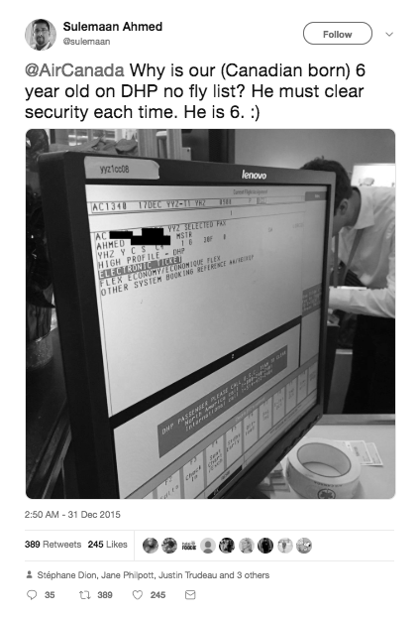

Source: Sulemaan Ahmed (@Sulemaan), “@AirCanada Why is our (Canadian born) 6 year old on DHP no fly list? He must clear security each time. He is 6. :),” Twitter, December 31, 2015, 2:50 a.m., accessed March 11, 2019, https://twitter.com/sulemaan/status/682514138573205505?lang=en.

EXHIBIT 2: Statistics on Sulemaan Ahmed’s December 31, 2015, Tweet

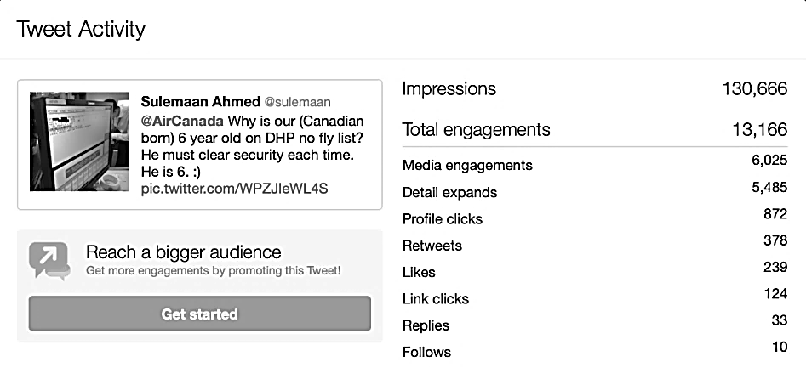

Notes: Impressions were equivalent to times a user was served a tweet in timeline or search results; Total engagements were the total number of times a user interacted with a tweet (e.g., through clicks anywhere on the tweet, retweets, replies, follows, likes, links, cards, hashtags, embedded media, username, profile photo, or tweet expansion); Media engagements were clicks to view a photo or video in a tweet; Detail expands were clicks on the tweet to view more details; Profile clicks were clicks on the name, @username, or profile photo of the tweet author; Retweets were times a user retweeted the tweet; Likes were times a user liked the tweet; Link clicks were clicks on a URL or card in the tweet; Replies were times a user replied to the tweet; and Follows were times a user followed you directly from the tweet.

Source: Sulemaan Ahmed (@Sulemaan), “@AirCanada Why is our (Canadian born) 6 year old on DHP no fly list? He must clear security each time. He is 6. :),” Twitter, December 31, 2015, 2:50 a.m., accessed November 12, 2018, https://twitter.com/sulemaan/status/682514138573205505?lang=en; Twitter Help Center, “About Your Activity Dashboard: What is the Tweet Activity Dashboard?,” accessed November 12, 2018, <https://help.twitter.com/en/managing-your-account/using-the-tweet-activity-dashboard>.

EXHIBIT 3: WestJet Customer Support correspondence to Zamir Khan, October 14, 2015

Source: Zamir Khan, Twitter post, January 3, 2016, accessed April 12, 2019, https://twitter.com/zam1rkhan/status/6838712  
87710580737.

EXHIBIT 4: Memo from Scott Bardsley to the *Globe and Mail*

From: Bardsley, Scott (PS/SP)

Sent: Monday, September 18, 2017, 9:21 AM

To: REDACTED*

Cc: Brien, Dan (PS/SP)

Subject: Correction request

Importance: High

Dear REDACTED*

The column today by Stephen Evans contains a significant error; it claims that:

“Every day at airports across Canada, thousands of people are being denied their mobility rights under Section 6 of the Constitution and the ability to board their flight simply because their name happens to match someone else’s name on the list.”

That is incorrect. The most common issue is that individuals (both adults and children) who have similar or the same names as individuals listed under the Secure Air Travel Act (SATA) are unable to check-in online or print a boarding pass at home. In these instances, travelers need to present themselves at a check-in counter so that the air-carrier can confirm they do not match an entry on the SATA list. This normally leads to a delay in the person’s travels of about 10-15 minutes.

To reiterate, a false positive typically causes a delay of 10-15 minutes, not the denial of boarding.

If you could correct Mr. Evan’s text online, it would be greatly appreciated.

(To be clear, we agree with his overall point and Bill C-59 takes an important first step towards a redress system for SATA.)

Scott

PS While I cannot comment on the operational details of the program for security reasons, you may wish to ask Mr. Evans for his source for the claim that it produces “thousands” of false positives “every day.”

Scott Bardsley

Press Secretary | Attaché de presse

Office of the Minister of Public Safety and Emergency Preparedness

Cabinet du ministre de la Sécurité publique et de la Protection civile

scott.bardsley@canada.ca | 613-998-5681

*Name redacted at request of NFLK.

Source: Scott Bardsley, email to *Globe and Mail*, September 18, 2017, courtesy NFLK group. Used with permission.

EXHIBIT 5: Excerpts from parliamentary Finance Committee Hearing  
October 20, 2017

[**Alexandre Boulerice:**](https://openparliament.ca/politicians/alexandre-boulerice/) **Rosemont–La Petite-Patrie, QC**

Thank you, Mr. Chair.

My first intervention isn’t a question, but a simple comment.

Mr. Ahmed and Ms. Cajee, I would like to tell you just how absurd I find the situation you have been fighting for months and years. This discrimination, particularly toward children, is scandalous. I think we’ve just hit the bottom of bureaucratic idiocy. I’m absolutely sorry that you have to come to the Standing Committee on Finance to assert the rights of your children, your friends, and your family members. It makes us all ashamed, and we have to resolve this issue.

That said, thank you for being here.

[**Tom Kmiec:**](https://openparliament.ca/politicians/tom-kmiec/) **Calgary Shepard, AB**

Thank you, Mr. Chair.

I’m going to start with No Fly List Kids, and then I’ll move to Mr. Goodis.

Mr. Fergus asked a lot of the questions I was going to ask. I just want to say that I look at your son, and he is about the same age as my oldest. I have three kids, and I can’t imagine what you go through. You have my sympathy and support, as well.

I also want to draw a parallel. I used to sit on the foreign affairs committee. We completed a report a few months ago where we offered recommendations to the government on changes to the Special Economic Measures Act. As well, we passed Bill [S-226](https://openparliament.ca/bills/42-1/S-226/), and it has received royal assent.

In that act, for cases of mistaken identity, we offer foreign nationals an opportunity to get off the sanction list Canada has. In the report the foreign affairs committee put together, we also say that, in cases of international sanctions, people with mistaken identity who wind up on no-fly lists and have their assets frozen should have a legal mechanism to seek redress. I find these two situations completely ridiculous—that we offer foreign nationals a better opportunity than we do for our kids here in Canada.

Source: Canada, Parliament, House of Commons Standing Committee on Finance, “Minutes of Proceedings and Evidence, 42nd Parliament, 1st Session, Number 119 (October 20, 2017), www.ourcommons.ca/DocumentViewer/en/42-1/FINA/meeting-119/evidence.

EXHIBIT 6: @NoFlyListKids Twitter Post, November 29, 2017

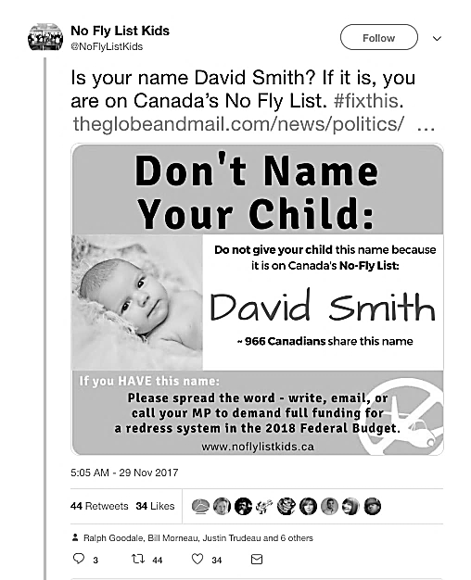

Source: No Fly List Kids (@NoFlyListKids), “Is your name David Smith? If it is, you are on Canada’s No Fly list,” Twitter, November 29, 2017, 5:05 a.m., accessed March 11, 2019, https://twitter.com/noflylistkids/status/935857289361100801?  
lang=en.

EXHIBIT 7: Sample Paper Airplanes and David Matthews with paper Airplanes

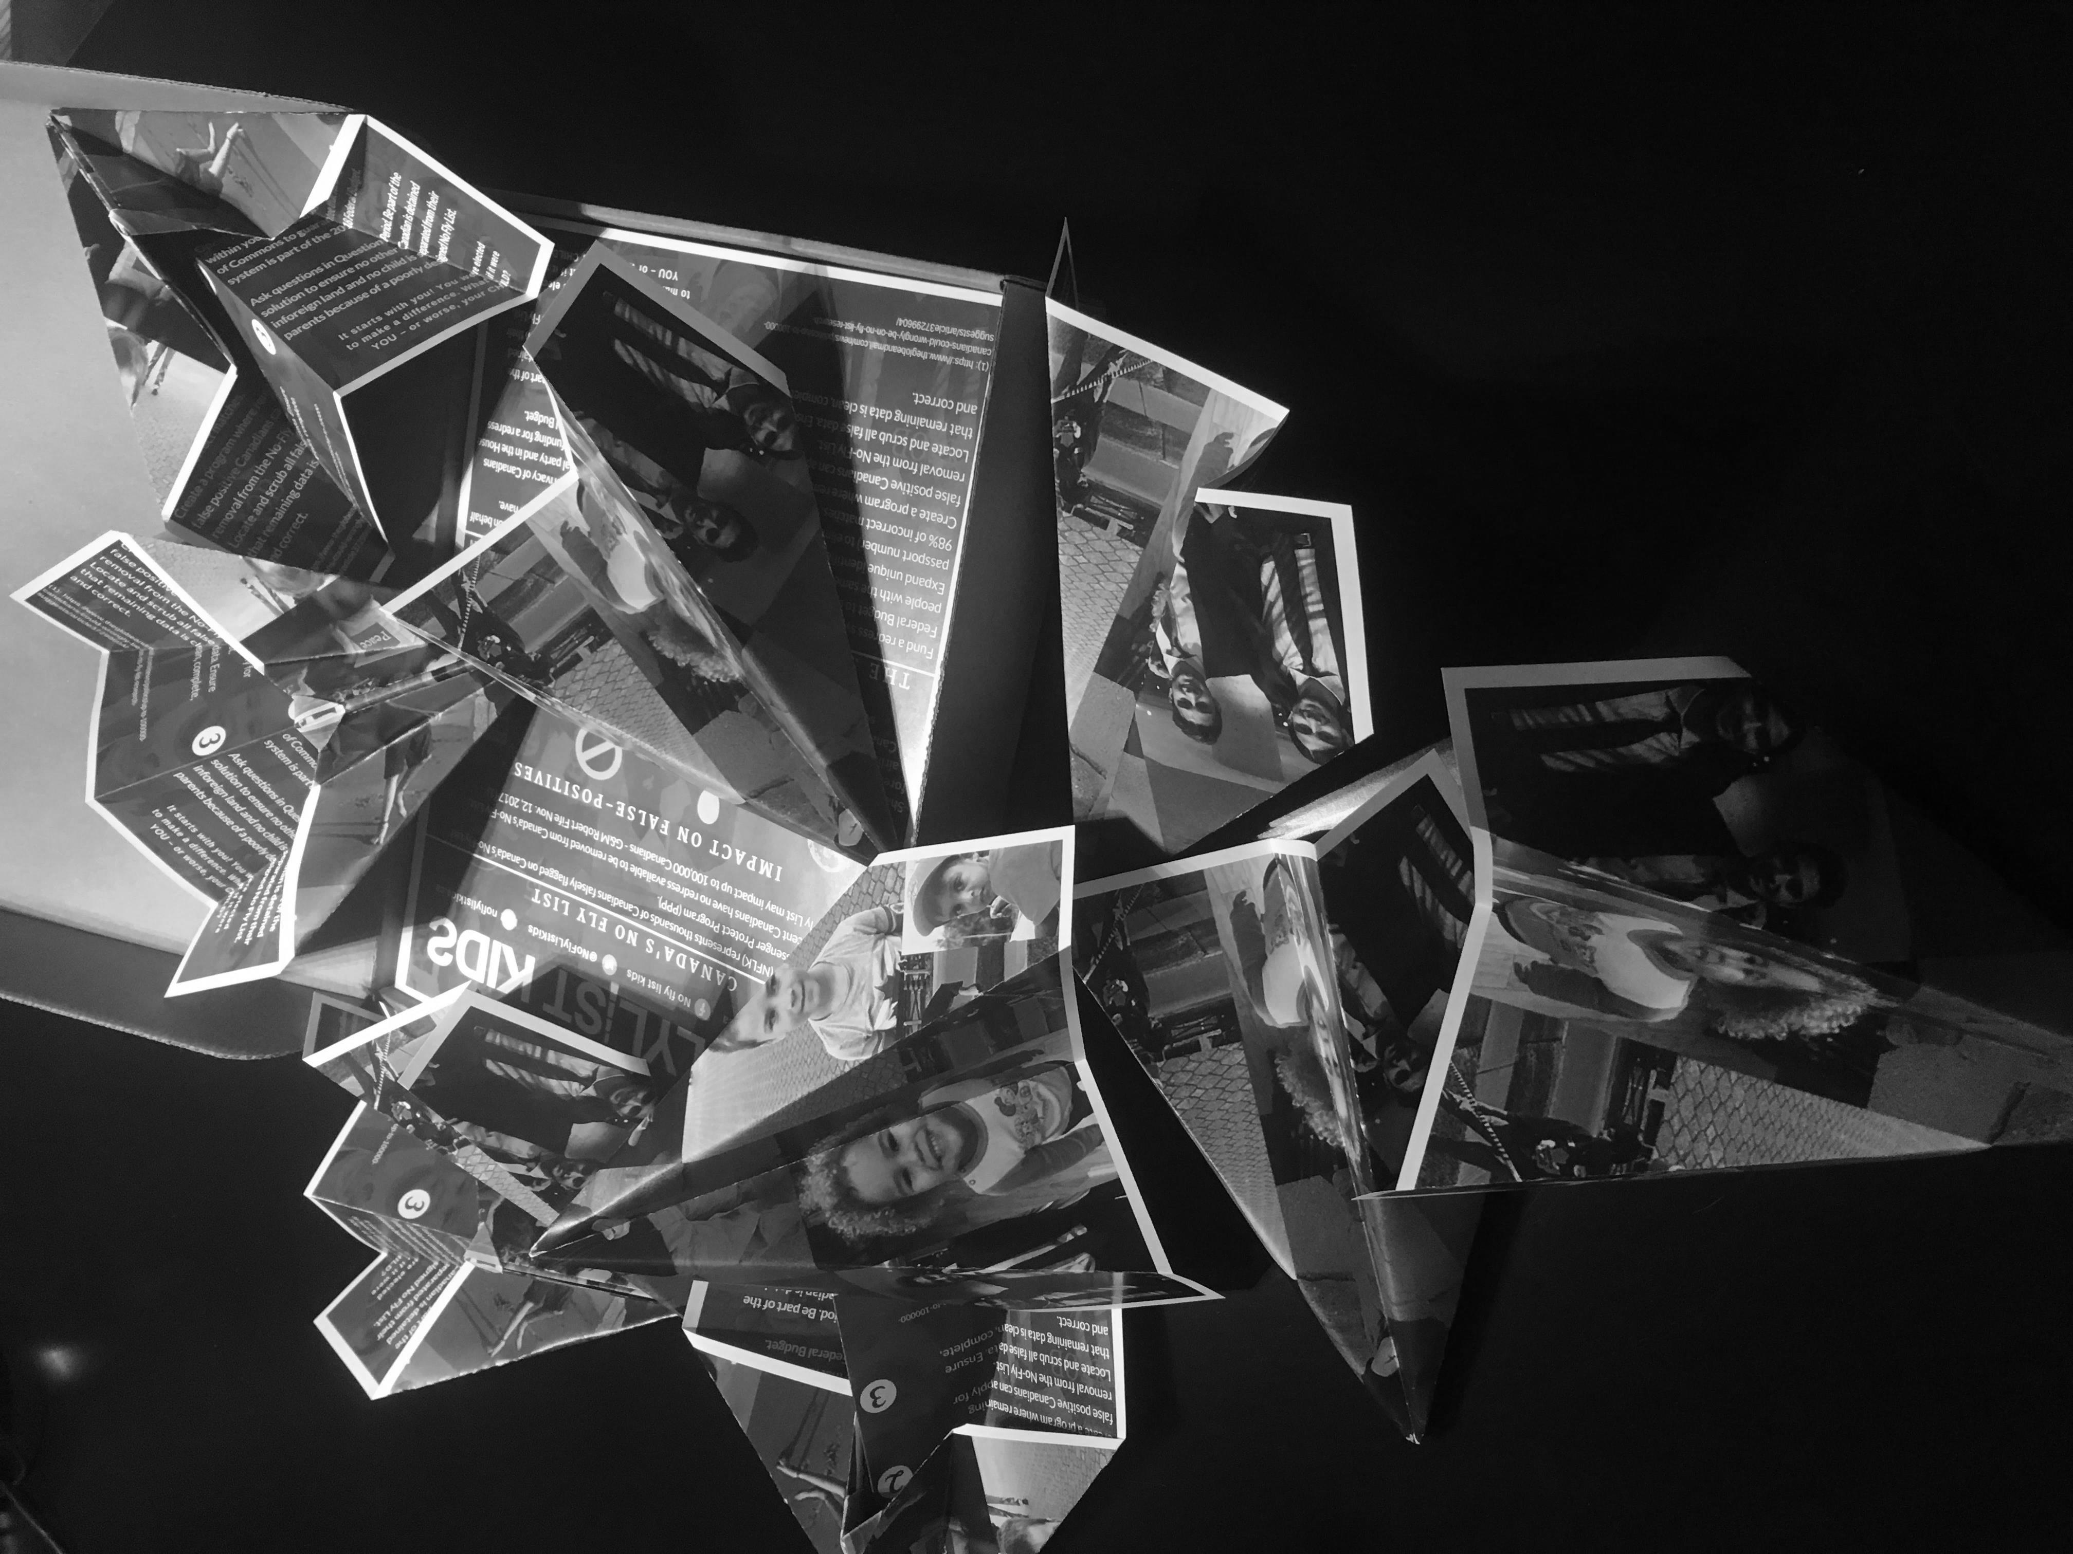

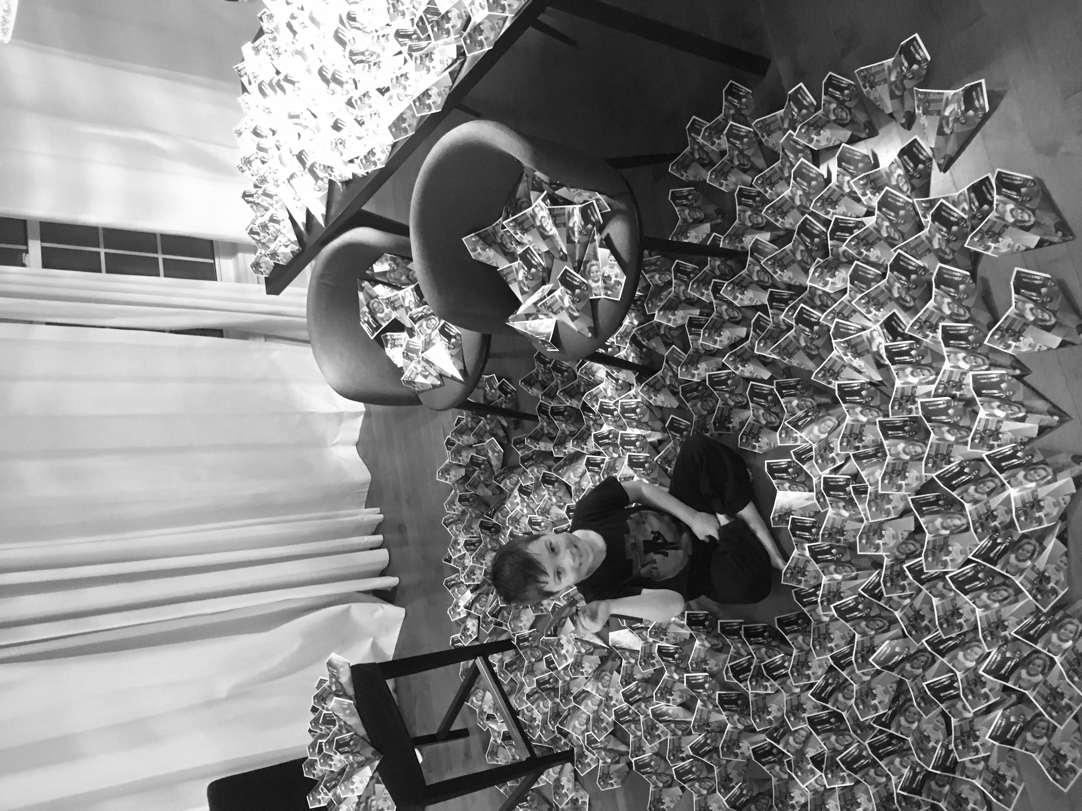

Source: Organization documents.

EXHIBIT 8: NFLK Group with Canadian Prime Minister Justin Trudeau

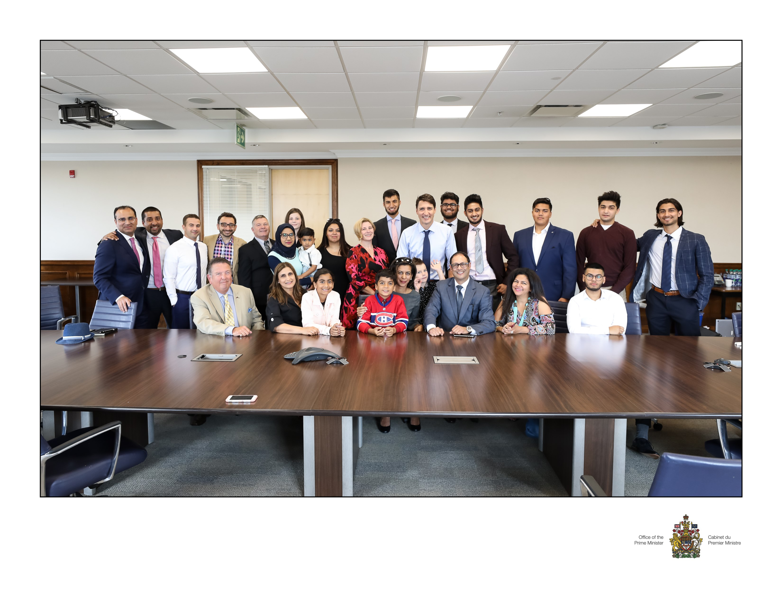

Source: Organization documents. Used with permission.

1. StarMetro Toronto, “Is This 18-Month-Old Really a Security Risk?,” Metro, January 4, 2016, accessed May 24, 2019, <https://issuu.com/metro_canada/docs/20160105_ca_toronto>.
2. The *Canadian Charter of Rights and Freedoms*, enshrined in the Canadian constitution, described the rights and freedoms of Canadian citizens and residents.
3. Shanifa Nasser, “Air Canada Employees Told to Seek Extra ID from Kids Even after Feds' Directive,” CBC News, May 11, 2016, accessed February 19, 2019, www.cbc.ca/news/canada/toronto/ralph-goodale-no-fly-list-air-canada-employee-aeroplan-1.3576417.
4. Sulemaan Ahmed, “Why are Canadian Children Still on No-Fly Lists – And What Can Be Done?,” Globe and Mail, June 27, 2016, accessed February 19, 2019, [www.theglobeandmail.com/opinion/why-are-canadian-children-still-on-no-fly-lists-and-what-can-be-done/article30629435/](http://www.theglobeandmail.com/opinion/why-are-canadian-children-still-on-no-fly-lists-and-what-can-be-done/article30629435/); The Habs was the nickname of the Montreal Canadiens hockey team.
5. Dean Beeby, “Kids Still Caught by No-Fly Lists Despite New Redress Office, Parents Say,” CBC News, January 27, 2017, accessed February 19, 2019, www.cbc.ca/news/politics/no-fly-kids-travel-aviation-redress-security-terrorist-public-safety-c51-1.3951403.
6. Robert Fife, “Ottawa Approves Redress System for Canadian Travellers Affected by No-Fly List,” Globe and Mail, November 20, 2016, accessed February 19, 2019, www.theglobeandmail.com/news/politics/ottawa-approves-redress-system-for-canadian-travellers-affected-by-no-fly-lists/article32947442/. All currency in Canadian dollars unless specified otherwise.
7. Stephen Evans, “Canada’s No Fly List is in Some Desperate Need of Some Innovation,” *Globe and Mail*, September 17, 2017, accessed February 19, 2019, www.theglobeandmail.com/report-on-business/rob-commentary/canadas-no-fly-list-is-in-desperate-need-of-some-innovation/article36284984/.
8. Scott Bardsley, email to *Globe and Mail*, September 18, 2017, courtesy NFLK group.
9. No Fly List Kids (@NoFlyListKids), “Is your name David Smith? If it is, you are on Canada’s No Fly list,” Twitter, November 29, 2017, 5:05 a.m., accessed March 11, 2019, https://twitter.com/noflylistkids/status/935857289361100801?lang=en.
10. International Civil Liberties Monitoring Group, “Canada’s No Fly List,” accessed March 11, 2019, https://iclmg.ca/issues/canadas-no-fly-list/.
11. No Fly List Kids (@NoFlyListKids), “100000 on the #NoFlyList That’s almost everyone on Cape Breton Island, NS Pop. 132,010 Home of the Cabot Trail, Fort Louisburg, Celtic music & great kitchen parties!,” Twitter, January 31, 2018, accessed March 11, 2019, <https://twitter.com/search?q=%40NoFlyListKids%20%E2%80%9C100000%20on%20the%20%23NoFlyList>  
    %20That%E2%80%99s%20almost%20everyone%20on%20Cape%20Breton%20Island%2C%20NS%20Pop.%20132%2C010&src=typd; No Fly List Kids (@NoFlyListKids); “100000 on the #NoFlyList That’s more than all of Nanaimo BC Pop 89,000 Beautiful harbour city, namesake of the dessert & famous for outdoor adventures,” Twitter, February 1, 2018, accessed March 11, 2019, <https://twitter.com/search?q=%40NoFlyListKids%20%E2%80%9C100000%20on%20the%20%23NoFlyList>  
    %20That%E2%80%99s%20more%20than%20all%20of%20Nanaimo%20BC%20Pop%2089%2C000%20&src=typd.
12. Sulemaan Ahmed (@Sulemaan), “The @noflylistkids families thanks Minister @RalphGoodale for his leadership. He met with us from Day 1 and we’ll keep working together until we get it done. Thank you sir,” Twitter, February 28, 2018, 8:36 a.m., accessed March 11, 2019, https://twitter.com/search?q=(%40Sulemaan)%2C%20%E2%80%9CThe%20%40noflylist

    kids%20families%20thanks%20Minister%20%40RalphGoodale%20for%20his%20leadership.%20&src=typd.
13. No Fly List Kids (@NoFlyListKids), “We’re honoured & grateful that PM @JustinTrudeau met with @NoFlyListKids families today to hear their stories and discuss the way forward. Together we will #fixthis! Oh Canada!,” Twitter, August 31, 2018, 10:34 a.m., accessed March 11, 2019, https://twitter.com/search?q=%E2%80%9CWe%E2%80%99re%20honoured%20%

    26%20grateful%20that%20PM%20%40JustinTrudeau%20met%20with%20%40NoFlyListKids%20&src=typd.
14. Bill C-59 was legislation related to national security matters, including the redress system, currently being debated in the Canadian Parliament; “Bill C-59, An Act Respecting National Security Matters,” 42nd Parliament, 1st Session, 2nd Reading in the Senate, December 11, 2018, accessed February 19, 2019, www.parl.ca/LegisInfo/BillDetails.aspx?Language=E&billId=9057418.